Ex1

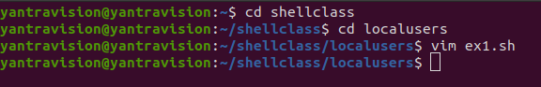
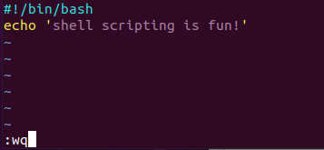
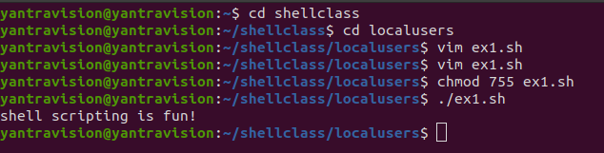

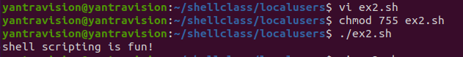
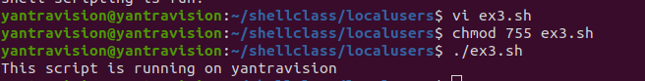
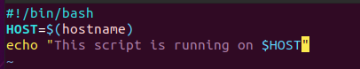
sxs
Sj
Ex2

Ex3

Ex4
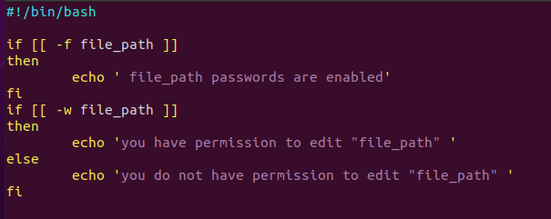
Ex4

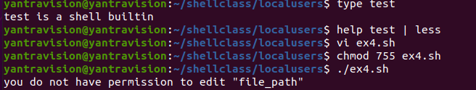
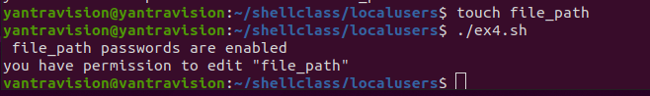
Ex 5

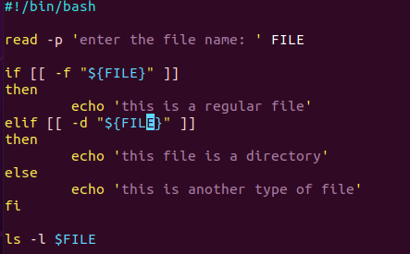

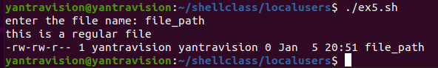

Ex 6
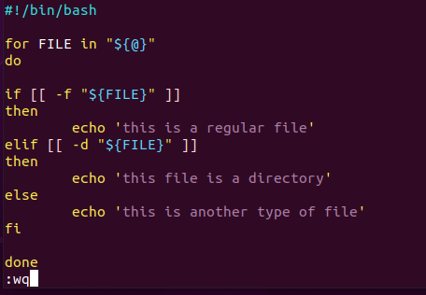

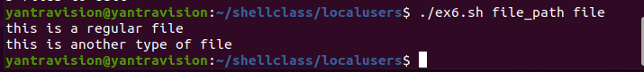
Ex 7

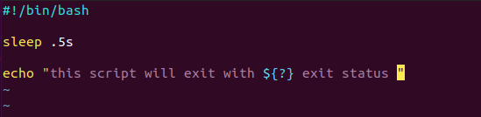

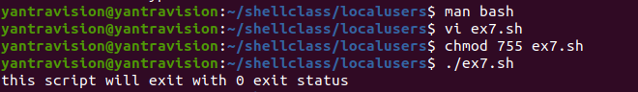
Ex 8

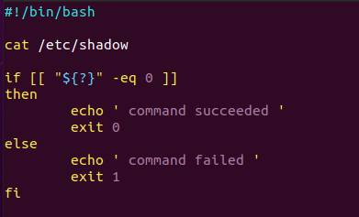

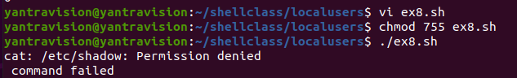
Ex 9
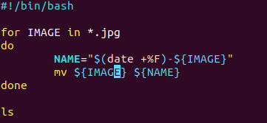

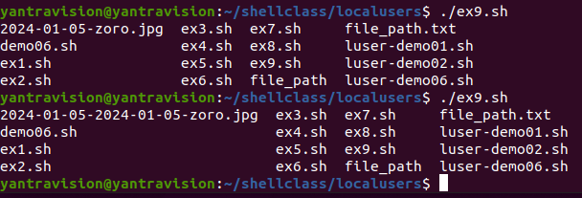
Ex 10

ln makes links between files
-s option makes symbolic links instead of hard links
symbolic links are reference to other files. If we access or modify the symbolic link, it affects the original
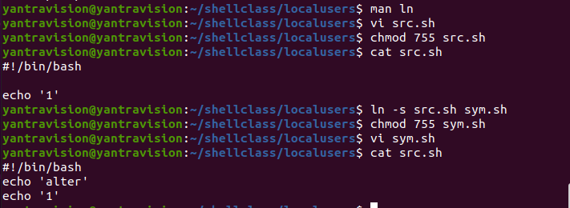
E

Ex 11

$? is a positional parameter which is special parameter that expands to the exit status of the most recently executed command

Ex 12

commands can be run at background using &
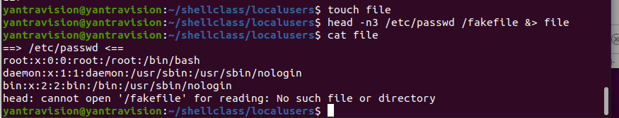
Ex 13

for <variable> in <folder/list>
do
commands
done
while [[ conditon ]]
do
commands
done
Ex 14

Name different commands that are available to check the disk usage
s



15. How will you find total shells available in your system?

cat /etc/shells

16. How to use pipe commands?

Its gives the output of one cammand to input to another cammand

echo "Hello" | head -c1

17 . How can I set the default rwx permission to all users on every file which is created in the current shell?

chmod 777 filename

18. How can we find the process name from its process id?

ps -p <process id>

19.significance of shebang

The shebang line tells the operating system which interpreter to use

20. How to get script name inside a script?

Echo “${0}”

21. How to check if the previous command was run successfully?

By using the ${?} we can check the exit status of the recently executed command if executed successfully then its zero.

22. How to get the last line from a file using just the terminal?

tail -n1 <filename>
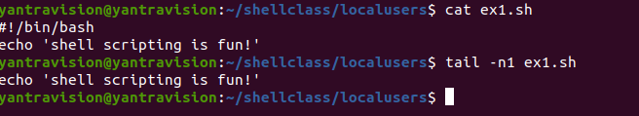

23. How to get the 3rd element/column from each line from a file?
awk '{print $n}' <filename>
$n points to the n’th column/field separated by spaces.
It will print the n th column from each line of the file.

